Module H – #H22 Teaching Guide
Appendix 1 Alternative Classroom Instructions

- Assign each student one of the following body systems integumentary, musculoskeletal, nervous, cardiovascular, respiratory, digestive, urinary, reproductive, endocrine, and immune systems.
- Explain they are to cover each topic listed on Handout #H22 for their assigned body system.
- The students will present their body system using the notes from current NC Nurse Aide I Curriculum - Module H power point and student manual.
- The instructor will facilitate the knowledge, making sure all aspects of the listed topics are covered.
- Students will complete Handout #H22 while listening to each student’s body system presentation.
- If there are more or fewer students than body systems, assign students in groups as needed.
- Students are to draw a diagram and label the organs of their assigned body system. The diagram should be created on a separate sheet of paper, at least 8 ½ x 11. The diagram on the worksheet is for reference only.
- Once all presentations have been presented to their class and students have filled in information in their Handout #H22, guide students in a cooperative learning Carousel strategy. Place posterboard titled for each body system, integumentary, musculoskeletal, nervous, cardiovascular, respiratory, digestive, urinary, reproductive, endocrine, and immune systems on the walls of the classroom. Divide students into groups depending on your class size and give them a colored marker to represent their group. Setting a timer for 1 minute, each group moves from board to board adding information they remember from the worksheet using their group’s colored marker. Allow each group to go to each posterboard a minimum of two times. Once two or more rounds are complete, bring the class back together and discuss in detail important points during the review noting anything omitted from the Carousel activity. The colored markers quickly identify groups who may need further education to make sure they have met all objectives of Module H.

The alternative assignment for Module H is a student-led module. Power points and student manual are to be used as references for students as they complete their assigned presentations. The instructor becomes the facilitator and not the direct line of knowledge until all activities for Module H have been completed. Make the assignment early in the course with an expected due date for presentations and Cooperative Learning Carousel Activity.
Module H Activities are still required to be completed. It is up to the instructor to determine when the activities will be completed as long as concluded by the last day of presentations and the Carousel activity noted above.
For further information related to cooperative learning strategy, Carousel, see links below.
https://shelleygrayteaching.com/carousel/
https://www.acteonline.org/teaching-strategy-the-carousel/

Handout #H-1 Body Systems
System | Integumentary | Musculoskeletal | Nervous | Cardiovascular | Respiratory
Function
Diagram | 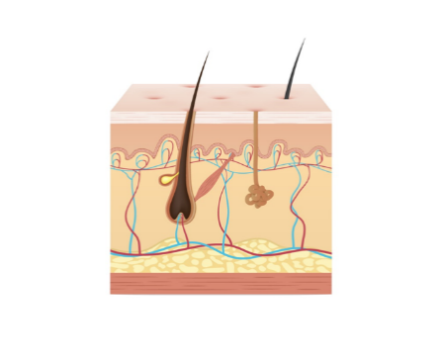 | 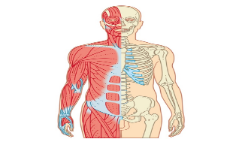 | 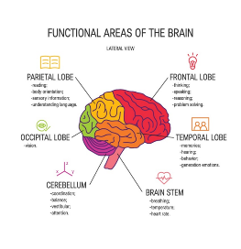 | 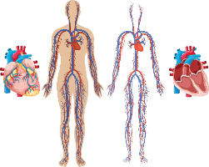 | 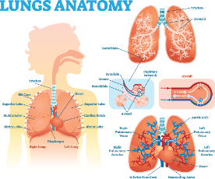
Organs
Disorders
Changes Due to Aging
System | Digestive | Urinary | Reproductive | Endocrine | Immune
Function
Diagram | 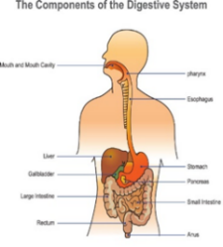 | 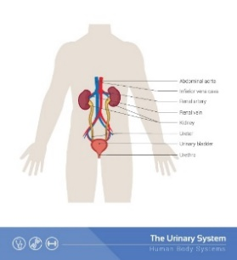 | 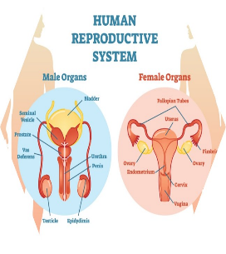 | 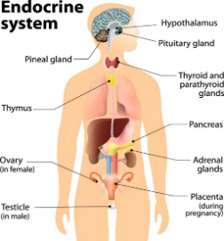 | 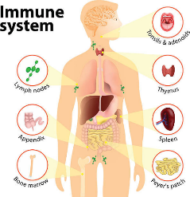
Organs
Disorders
Changes Due to Aging

